# Name: Abiral Chaudhary

# Roll No: 221702

**Assignment 1**

1. **Whenever you type some URL in a browser’s address bar and hit enter, a lot of activities occur behind the scenes including finding the correct server and obtaining the required documents from it. Now explain all of the behind the scene activities in detail.**

➤ For example, if we enter <https://pu.edu.np> into a browser, then background activities that happen is explained below:

1. **URL Parsing:**

The browser parses the URL and breaks down the URL into its components: the protocol (https), the domain name (pu.edu.np) and the path to the specific resource on the server.

1. **DNS Lookup:**

Once the domain name is extracted, the browser performs a DNS (Domain Name System) Lookup to find the IP address associated with the domain. DNS is a massive database of millions of registered domain names, each associated with a particular website's name-server and IP address. The browser sends a Lookup request (DNS query) to a DNS server, which responds with the IP address associated with the domain name.

1. **Establishing a TCP Connection:**

Knowing this IP, the browser then establishes a TCP (Transmission Control Protocol) connection with the server that hosts the website through the IP address. This connection is established through the Internet Protocol (IP). This whole process is known as "handshake".

1. **Firewall Check:**

If your computer is behind a firewall, the firewall checks to ensure that the particular request we are making is allowed before permitting it. Also, if the server we are trying to access is also behind a firewall, a similar check will be done before the connection is finally made with the server.

1. **SSK/ TLS Handshake:**

After establishing the connection, if the protocol is "https", the browser and the server performs a Secure Sockets Layer (SSL) or Transport Layer Security (TLS) handshake to establish a secure connection.

1. **Sending an HTTP Request**:

Once the secure connection is established, the browser sends an HTTP (Hypertext Transfer Protocol) Request to the server. The request includes the HTTP method (e.g. GET, POST), the requested resource path, headers (such as cookies, etc.) and other relevant information.

1. **Server Processing:**

Upon receiving the request, the server processes it. This may include various tasks, such as verifying the request, handling session management and preparing the response.

1. **Generating Response:**

The server generates an HTTP response containing the requested resource, such as a HTML document. It includes a state code (e.g. 200 for success, 400 for not found), response headers (e.g. content type) and the requested content.

1. **Data Transfer:**

The server sends the HTTP response back to the browser over the established TCP connection. The response travels through the internet in small packets.

1. **Rendering The Content:**

The browser receives the response and starts rendering the content. It interprets HTML, CSS, JavaScript, and constructs the Document Object Model (DOM) representing the structure of the web page.

1. **Additional Request:**

While parsing the retrieved content, the browser may encounter additional requests for external resources. When encountered, it repeats the process of DNS Lookup, establishing TCP connections, and fetching those resources.

1. **Displaying the Web Page:**

Once all the necessary resources are fetched and processed, the browser combines them to render the final web page.

1. **To make an online presence or just transfer any data there are certain predefined rules to follow. Explain any 5 such commonly used protocols that serve different purposes of their own.**

➤ Internet Protocol (IP) is a protocol or set of rules for routing and addressing packets of data so that they can travel across networks and arrive at they can travel across networks and arrive at the correct destination.

Any five commonly used protocols are:

1. **SNTP (Simple Mail Transfer Protocol):** SMTP is a communication protocol used for delivering email messages from the sender's mail server to a recipient's mail server. The protocol uses the header of the mail to get the mail id of the receiver and enters the mail into the queue of outgoing mail. And as soon as it delivers the mail to the receiving email id, it removes the email from the outgoing list.
2. **POP (Post Office Protocol):** POP is an internet standard protocol which works on the application layer of OSI reference model and is used by the local email software in order to retrieve emails from the remote email server over the TCP/ IP connection. POP does not allow any search facility. As this protocol supports offline access to the message and so less internet usage time is required by this.
3. **IMAP (Internet Message Access Protocol):** IMAP is a standard protocol for accessing and managing email messages on a remote mail server. It allows you to access your email messages from multiple devices. You can keep your email messages on the server and free up space on your local device. It allows you to organize your email messages into folders on the server.
4. **FTP (File Transfer Protocol):** FTP is a client server protocol that relies on two communication channels between client and server: a command channel for controlling the conversation and a data channel for transmitting the file content. It is a standard internet protocol provided by TCP/IP used for transmitting the files from one host to another.
5. **HTTP (HyperText Transfer Protocol):** HTTP is a protocol used to access the data on the World Wide Web (WWW). It can be used to transfer data in the form of plain text, hypertext, audio, video, and soon. It is similar to FTP as it also transfers files from one host to another host. But, HTTP is simpler than FTP as HTTP uses only one connection i.e. no control connection to transfer the files.
6. **Explain about www and internet. How is domain name conversion carried out?**

➤ WWW is an information system on the internet which allows documents to be connected to other documents by hypertext links, enabling the user to search for information by moving from one document to another. In simple words, it is a collection of websites or web pages stored in web servers and connected to local computers through the internet. In 1989, Tim Berners Lee, an English scientist created [WWW. WWW](http://www.www) was initially known as NSFNET. The building blocks of WWW are web pages which are formatted in HTML and connected by hypertext links or hyperlinks and accessed by HTTP.

Internet is a global computer network or network of networks providing a variety of information and communication facilities, consisting of interconnected networks using standardized communication protocols. It was developed in the 1960s and funded by the US Department of Defense. It was first known as ARPANET (Advanced Research Project Agency). The Internet uses TCP/IP to communicate between networks and devices. The Internet Provides a capability so powerful and general that it can be used for almost any purpose that depends on information.

Domain name conversion is carried out by:

1. The user enters a domain name (e.g. [www.google.com](http://www.google.com)) into the browser and the browser sends the domain name to the DNS server.
2. The resolver queries a DNS root name server.
3. The root server responds to the resolver with the address of a TLD DNS server (.com).
4. The resolver then makes a request to the TLD (.com).
5. The TLD server responds with the IP address of the domain's name server (google.com).
6. The DNS resolver sends a query to the domain nameserver.
7. The IP address for google.com is then returned to the resolver from the nameserver.
8. The DNS resolver responds to the web browser with the IP address of the domain requested initially.
9. **Differentiate between the Web and the Internet.**

➤The differences between the Web and the Internet are:

| **Web** | **Internet** |
| --- | --- |
| a).It is a system of interconnected hypertext documents and resources accessed through the Internet. | a).It is a global network of interconnected computers and networks. |
| b).The components of the web are web pages, web servers, web browsers, web clients. | b).The components of the Internet are computers, routers, servers, networking protocols. |
| c).It relies on protocols like HTTP, HTML, CSS, and Java Script. | c).It relies on networking protocols like TCP/IP, DNS, and SMTPL. |
| d).In 1989, Tim Berners Lee, an English scientist, created the web. | d).It was developed in the 1960s. |
| e).Web was initially known as NSFNET (National Science Foundation Network). | e).The first version of the internet was ARPANET (Advanced Research Project Agency Network). |
| f).E.g. websites, web applications, online services like search engines and social media. | f).E.g. online services, email clients, online gaming platforms, ftp etc. |

1. **Write short notes on a Fully Qualified domain name with examples.**

➤ Fully Qualified domain name (FQDN) is the most complete domain name that identifies a page, host, server or any other online resource.

It is a domain name that specifies its exact location in the DNS hierarchy tree; it specifies all domain levels, including the Top-Level Domain and the Root Level.

The DNS hierarchy, also called the domain name space, is an inverted tree structure. The DNS hierarchy tree has a single domain at the top of the structure called the root domain – indicated by the “.” as we have mentioned above. Below the root domain are the top-level domains that divide the DNS hierarchy into segments containing second-level domains, sub-domains, and hosts. Hence, the DNS hierarchy consists of the following five levels: Root Level Domain, Top Level Domains (TLD), Second Level Domains (SLD), Subdomains, hosts. For e.g.:

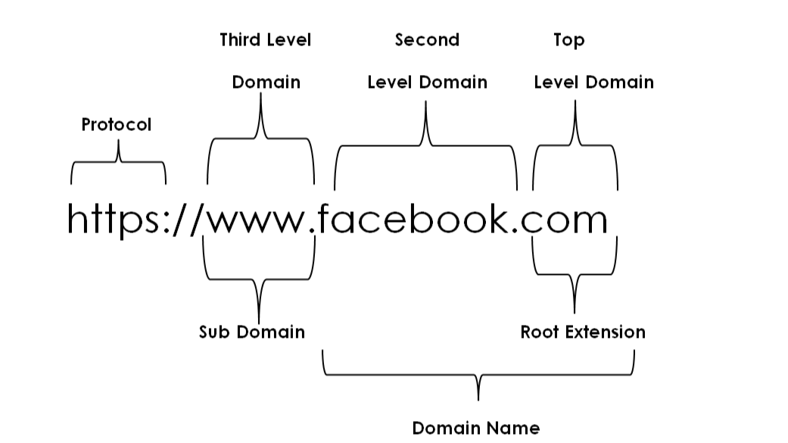

1. **What is a web browser? Differentiate between FTP and HTTP.**

➤ A web browser (commonly referred to as a browser) is a software application for accessing information on the World Wide Web. It is a software application that allows users to access and view websites on the World Wide Web. Web browsers interpret HTML, CSS, JavaScript, and other web technologies to render and display web pages to users.

The differences between FTP and HTTP are as follows:

| FTP | HTTP |
| --- | --- |
| **.** It is a protocol that works on client-server architecture and allows the process of uploading and downloading files from a computer over the internet. | **.** It is a protocol that works on client-server architecture and allows the process of transferring various computers present on the internet. |
| **.** It supports both data connection and control connection. | **.** It only supports data connection. |
| **.** It requires authentication. | **.** It does not require authentication. |
| **.** This protocol is state-full. | **.** This protocol is stateless. |
| **.** It uses a two way communication system. | **.** It uses a one way communication system. |

## 7. Differences between SMTP and POP.

➤

| **SMTP** | **POP** |
| --- | --- |
| The term SMTP short form for Simple Mail Transfer Protocols. | The term POP short form for POst Office Protocol. |
| It is used for sending messages. | It is used for accessing messages. |
| The port number of SMTP is 25, 465, and 587 for secured connection (TLS connection). | The port number of POP3 is 110 or port 995 for SSL/TLS connection |
| It is an MTA (Message Transfer Agent) for sending the message to the receiver. | It is an MAA (Message Access Agent) for accessing messages from mailboxes. |
| SMTP is also known as the PUSH protocol. | POP3 is also known as POP protocol. |
| SMTP transfers the mail from sender’s computer to the mailbox present on receiver’s mail serve | POP3 allows you to retrieve and organize mail from the mailbox on the receiver mail server to the receiver's computer. |
| It is implied between sender mail server and receiver mail server. | It is implied between receiver and receiver mail server. |

## 8.Differences between URI and URL.

➤

| **URI** | **URL** |
| --- | --- |
| The term URI short form for Uniform Resource Identifier. | The term URL short form for Uniform Resource Locator. |
| URI is the superset of a URN and a URL. | URL is the subset of URI. |
| URI identifies a resource and differentiates it from others by using a name, location, or both. | URL identifies the web address or location of a unique resource. |
| URI contains components like a scheme, authority, path, and query. | URL has similar components to a URI, but its authority consists of a domain name and port. |
| An example of a URI is **ISBN 0-476-35557-4.** | An example of a URL would be **https://hostinger.com.** |
| URI scheme can be a protocol, a specification, or a designation like HTTP, file, or data. | URL scheme is a protocol, such as **HTTP and HTTPS**. |
| URI is usually used in XML, tag library files, and other files, such as JSTL and XSTL. | URL is mainly for searching web pages on the internet. |

## 

**9. Differences between LAN, MAN, and WAN.**

➤

| **LAN** | **MAN** | **WAN** |
| --- | --- | --- |
| LAN stands for Local Area Network. | MAN stands for Metropolitan Area Network. | WAN stands for wide area network. |
| LAN’s ownership is private. | MAN’s ownership can be private or public. | While WAN also might not be owned by one organization. |
| LAN’s ownership is private. | MAN’s ownership can be private or public. | While WAN also might not be owned by one organization. |
| Operates in small areas such as the same building or campus. | Operates in large areas such as a city. | Operates in larger areas such as countries or continents. |
| The transmission speed of a LAN is high | While the transmission speed of a MAN is average. | Whereas the transmission speed of a WAN is low. |
| The propagation delay is short in a LAN. | There is a moderate propagation delay in a MAN. | Whereas, there is a long propagation delay in a WAN. |
| LAN’s design and maintenance are easy. | While MAN’s design and maintenance are more difficult than LAN. | Whereas WAN’s design and maintenance are also more difficult than LAN as well as MAN. |

## 

**10.What is MIME? Explain its headers.**

➤ MIME stands for Multipurpose Internet Mail Extensions. MIME is an email extension protocol which allows both ASCII and non-ASCII data to be sent via email. IT also lets users exchange audio, video, images and application programs, over email.

MIME headers are:

1. **MIME Version:** It defines the version of the MIME protocol. This header usually has a parameter value 1.0, indicating that the message is formatted using MIME.
2. **Content Type:** It describes the type and subtype of information to be sent in the message. These messages can be of many types such as text, image, audio, video. They also have many subtypes such that the subtype of the image can be png or jpeg. Similarly, the subtype of videos can be webm, mp4, etc.
3. **Content Type Encoding:** In this field, it is told which method has been used to convert mail information into ASCII or binary number, such as 7-bit encoding, 8-bit encoding, etc.
4. **Content Id:**In this field, a unique "Content Id" number is appended to all email messages so that they can be uniquely identified.
5. **Content Description:** This field contains a brief description of the content within the email. This means that information about whatever is being sent in the mail is clearly in the "content Description".
6. **Content Disposition:** This header provides information about how to present a message or body part. When a body part has an attached file, this header will include a file name parameter.

**11.Explain the evolution of the internet and the web.**

➤ In the 1960's the U.S. Department of Defense (DoD) became interested in developing a new large scale computer network in the 1960s. The purpose of this network were communications, problem sharing, and remote computer access for researchers working on defense related contracts. One fundamental requirement was that the network be sufficiently robust. As it was funded by DoD's Advanced Research Projects Agency (ARPA), the network was called ARPANET. The primary use of ARPAnet was simple text-based communication through email.

In 1989, a small group of people led by Tim Berners Lee at CERN (European Council for Nuclear Research) proposed a new protocol for the Internet as well as a system of document access to use it. The intent of this new system, which the group named the World Wide Web, was to allow scientists around the world to use the Internet to exchange documents describing their work. The proposed new system was designed to allow a user anywhere on the Internet to search for and retrieve documents from a database on any number of different document serving computers.

**12. Explain CMS (Content Management System).**

➤CMS is a software that helps users create, edit, collaborate, publish and store digital content.

CMS are typically used for ECM (Enterprise Content Management) and WCM (Web Content Management).

CMS provides a graphical user interface with tools to create, edit and publish web content without the need to write code from scratch CMS has two components. They are:

1. **CMA (Content Management Application):** It enables users to design, create, modify and remove content from a website without developer knowledge.
2. **CDA (Content Delivery Application):** It provides the backend services that support management and delivery of the content once a user creates it in the CMA.

**Some features of CMS are:**

* **Intuitive indexing, search and retrieval:** These features index all data for easy access through search functions and enable users to search by attributes such as publication dates, keywords or author.
* **Format management:** This helps turn scanned paper documents and legacy electronic documents into html or pdf documents.
* **Revision features:** These features enable content to be updated and edited after initial publication. Revision control also tracks any changes individuals make to files.
* **Publishing:** This functionality enables individuals to use a template or a set of templates that an organization approves for content creation and modification.

**13. What is tier technology? Explain 1,2,3, and N tier technology with their differences.**

➤Tier technology is a software architecture that consists of a presentation tier that communicates with other 2 tiers, an application tier where data is processed and a data tier that stores information.

* **1 Tier Technology:** It has a presentation layer, application layer (business layer) and database layer at the same tier i.e. at Client Tier. All the layers and components are available on the same machine. MP3 player MS Office etc. are some of the examples. The data is stored on the local system or shared drive. 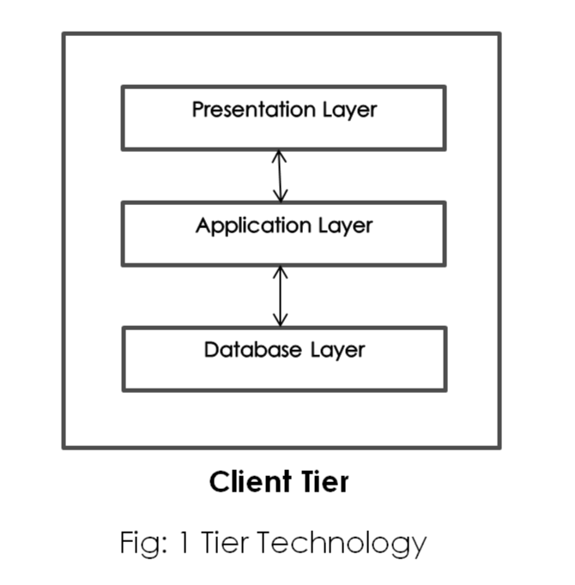
* **2 Tier Technology:** The client tier handles both presentation and application layers and the server handles the database layer. It is also known as "Client Server Application". The communication takes place between client and server. Client sends request to the server and server processes the request and sends back the data to the client.

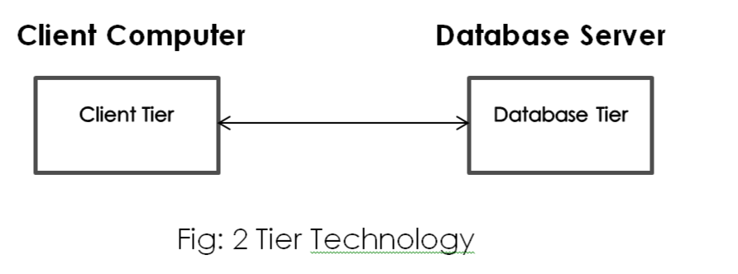

* **3 Tier Technology:** The client tier handles the presentation layer, the application server handles the application layer and the server system handles the database layer. In this, all three layers are located in separate machines.

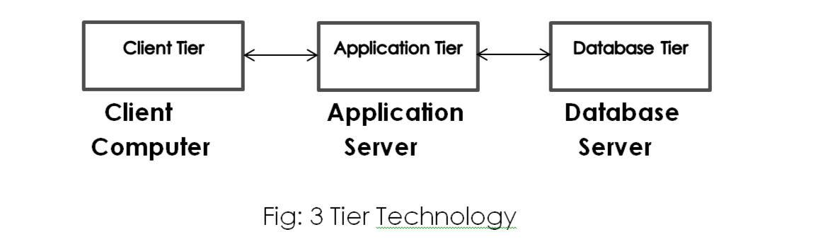

* **N Tier Technology:** It is also called a Distributed Architecture or Multi-Tier Architecture. It is similar to 3 tier technology but the number of the application server is increased and represented in individual tiers in order to distribute the business logic so that the logic can be distributed.

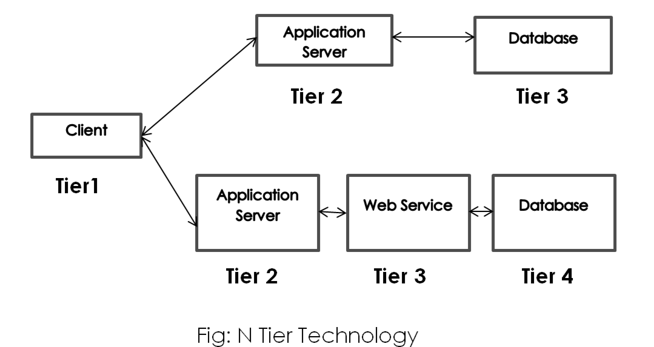

**14. Why is HTTP called stateless and connectionless?**

➤ HTTP is called stateless protocol because both the client and server know each other only during the current request. Due to the nature of the protocol, both the client and server do not retain the information between various requests of the web pages.

HTTP is called a connection protocol because the http client initiates a request and waits for a response from the server. When the server receives the request, the server processes the request and sends back the response to the HTTP client after which the client disconnects the connection. The connection between the client and server exists only during the current request and response time only.

**15. The company wants to convert its website from http to https by seeing other websites but is unknown about its advantages. By explaining its advantages, how would you convert its website from HTTP to HTTPS?**

➤ Converting a website from http to https has several advantages, both in terms of security and user experience. Some of the key advantages are:

1. **Data Security:** HTTPS ensures secure communication between website and user's browser by encrypting the data transmitted. This encryption helps protect sensitive information such as login credentials, credit card details from being tampered or intercepted.
2. **Authentication and Trust:** HTTPS uses SSL/TLS certificates to establish an encrypted connection. These certificates provide authentication, verifying that the website is trustworthy.
3. **Search Engine Ranking:** Search engines like Google consider HTTPS as a ranking factor; websites with HTTPS tend to rank higher in search results compared to the websites with HTTP. Migrating to HTTPS improves website's visibility and attracts more organic traffic.
4. **Browser Warning:** Modern web browsers such as chrome, display warnings to users when they visit an HTTP website. These warnings indicate that the connection is not secure. By migrating to HTTPS you eliminate these warnings, providing a smoother user experience.

To convert a website from HTTP to HTTPS, you should:

1. **Obtain an SSL Certificate:** We can obtain an SSL certificate directly from any web hosting company.
2. **Check the hosting environment:** We should ensure that our hosting environment supports SSL. We can contact our hosting provider if we need to upgrade our hosting plan to enable SSL.
3. I**nstall SSL certificate:** The process of installing an SSL certificate is automatic in some hosting providers, while others may require manual installation. Follow the instructions provided by the hosting provider.
4. **Update internal and external links:** Once SSL certificate is installed, update all internal and external links on the website to use HTTPS protocol instead of HTTP.
5. **Implement 301 redirects:** Set up 301 redirects to redirect all HTTP URLs to HTTPS versions. This ensures that visitors who try to access websites using HTTP are automatically redirected to the secure HTTPS version.

**16. Differences between the Internet, Intranet and Extranet.**

➤

| **Internet** | **Intranet** | **Extranet** |
| --- | --- | --- |
| a).It is open to the public. | It can be accessed via the internet, although its authentication requires logging in. | It is mostly used by businesses to limit access to secret information. |
| b).It is owned by no one. | It is owned by a particular company/organization. | It is owned by a single/multiple organization. |
| c).Everyone who is linked has access to it. | Only members of the organization have access to it. | Only members of the organization and external members with logins have access. |
| d).Its goal is to provide information all across the world. | Its goal is to communicate within the company. | Its goal is to allow members and external members to share information. |
| e).It is more economical to use in comparison to intranet and extranet. | It is less economical. | It is also less economical. |

**17. What is web architecture? Explain different types of web architecture**.

➤ Web architecture is the overall structure of a website or web application, including the way it is designed, implemented, and deployed.

Types of web architecture are:

1. **Single Page Application (SPA):** Instead of loading completely new pages from the server each time for a user action, SPA allows dynamic interaction by providing updated content to the current page. This helps in interactive user experience.
2. **Microservice Architecture:** These are small services that execute a single functionality. It allows developers to not only enhance productivity but also speed up the entire deployment process. The components making up an application build using this architecture are not directly dependent on each other. Due to this, they don't need to be necessarily built using the same programming language.
3. **Serverless Architecture:** In this, applications are built and run on servers managed by third party cloud service providers like amazon and Microsoft. It allows you to focus on the quality of the product.
4. **Progressive Web Application (PWA):** This architecture provides additional features such as increased performance speed, offline functionality, home screen installation. It allows functioning on any browser and on any device.

**18. What are web standards? Explain any 3 web standards. What are the advantages of using web standards?**

➤ Web standards are guidelines or formal set of standards used to define and describe aspects of www. It promotes consistency in design code which makes up a web page.

Any 3 web standards are:

1. **HTML (Hyper Text Markup Language):** HTML is the standard markup language used for creating and structuring web pages. It provides a set of tags and attributes that define the structure and content of a web document. It allows you to specify headings, paragraphs, lists, links, images, and various other elements.
2. **CSS (Cascading Style Sheets):** CSS is a web standard used for describing the presentation and layout of a document written in HTML. It allows web designers to control the appearance of elements on a web page, including the colors, fonts, sizes, spacing and positioning.
3. **Java Script:** Java Script is a standard programming language that allows you to add interactivity and dynamic functionality to web pages. It enables action such as form validation, image slideshow interactive maps, and real time updates.

The advantages of using web standards are:

1. **Improves search engine ranking:** Web standards do not allow a lot of clutter in the code. With less clutter, it makes it easier for search engines to evaluate and examine the web site.
2. **Reducess development and maintenance time:** Coding in accordance with standards shortens both development and maintenance time. Debugging and troubleshooting therefore becomes easier, because the code follows a pattern.
3. **Developer Friendly:** Web standards offer a set of rules that every developer can follow, understand, and become familiar with. When one developer builds a site according to standards, another will be able to pick up where the former left easily.

**19. Explain Client server operation in detail with the necessary diagram.**

➤The operation in which there is a dedicated client and a dedicated server where client requests a service from server and server provides the requested service to the client after processing the request.

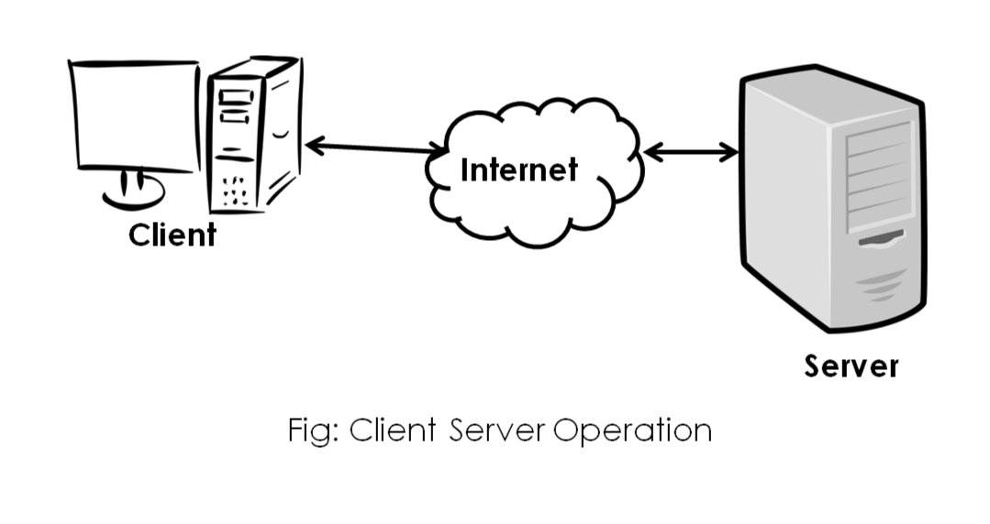

The client is a user's device. The server is a dedicated device designed to handle multiple client requests simultaneously.

The client and server can be physically separate devices connected over a network such as the internet.

In this operation, the client requests a service or resource to the server. The request can be for various purposes such as sending an email, opening a web page.

The server processes the received request and generates information or indicates the outcome of the operation.

To establish communication between client and server, communication protocols such as HTTP, FTP, SMT, TCP/IP is used

**20.Web browser and Web server for internet explain.**

➤ A web browser and web server are two key components of the internet that work together to facilitate the exchange of information and enable users to access and interact with websites.

Web browser commonly known as browser, is a software application for accessing information on the World Wide Web. It is a software application that allows users to access and view websites on the World Wide Web.

Web server is a server software that can satisfy WWW. It processes incoming network requests over HTTP and several other related protocols.

**21. What is the impact of the web in today's world?**

➤ The key impacts of the web in today's world is:

1. **Communication:** The web has transformed communication by making it easier, faster and more accessible. It has enabled global collaboration, strengthened social connections and facilitated the sharing of ideas and information.
2. I**nformation Access:** Web allows people to find information on any topic virtually with a single search. Web provides access to news websites, educational resources, and digital libraries which provide a lot of information.
3. **Entertainment**: The Web has revolutionized the entertainment industry. Users can easily access a variety of movies, TV shows, and music easily. The Web has given rise to new forms of content creation and distribution.
4. **E-commerce:** Web enables e-commerce platforms. This allows consumers to purchase goods and services from anywhere easily. It has facilitated the growth of online marketplaces, digital payments and global reach of business.
5. **E-learning:** Web has transformed the field of education. Online learning platforms and educational websites provide access to educational resources and courses to students easily.

**22. Let us assume a scenario where person (A) sends an email to person (B) and person (B) responds to person (A). Now explain the sending and receiving process of email.**

➤ The sending and receiving process of email from person (A) to person (B) is explained.

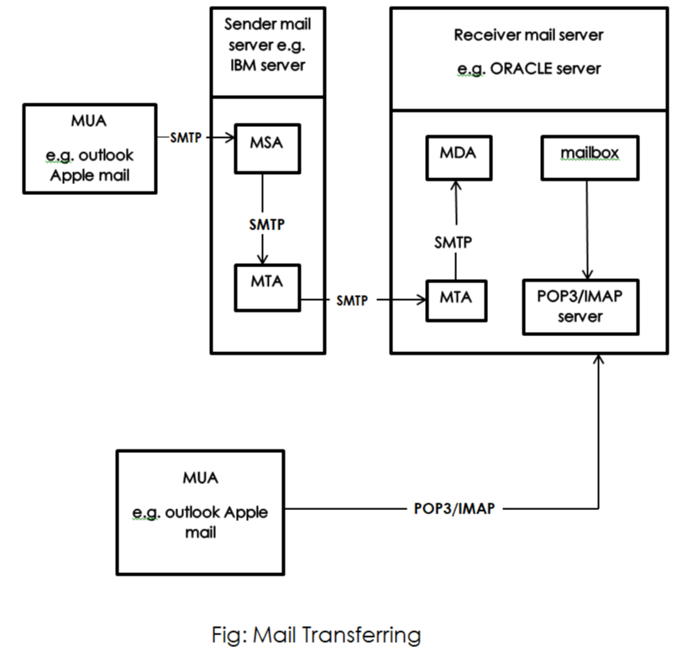

1. Person (A) uses their MUA (Mail User Agent) to compose the email and enters send.
2. MSA (Mail Submission Agent) present in the sender mail server receives the composed mail from MUA. MUA uses the SMTP protocol to establish the connection with MSA. MSA verifies the email's formatting, attachments, and compliance with email standards.
3. MSA sends the email to MTA (Mail Transfer Agent) Present in the sender mail server using SMTP protocol.
4. MTA on the sender side performs a DNS Lookup to find MTA present at the receiver side. After finding, MTA at sender side delivers the email to MTA at receiver side which stores the email temporarily.
5. MDA (Mail Delivery Agent) retrieves the email from MTA at the receiver mail server.
6. MDA then delivers the email to the recipient mailbox. MDA may use POP 3 (Post Office Protocol version 3) or IMAP (Internet Message Access Protocol) to enable access to the mailbox.
7. The POP3/IMAP server then retrieves the email from the mailbox.
8. Person (B) uses their MUA to connect to the receiver mail server using POP3/IMAP. POP3 typically downloads the email to the server. IMAP allows for remote access and synchronization of emails across multiple devices.
9. Person (B) can now view the received email. The process repeats in reverse when person (B) responds to person (A).

**23.How to register a domain name? Differentiate top-level and second-level domains.**

➤A domain name is registered by following ways:

1.Find a domain name registrar.

2.Search for your domain name.

3.Finalize your domain name choice.

4.Choose a domain name suffix, such as .com or .net.

5.Purchase the domain name.

6.Add Domain ID protection.

7.Verify ownership

**1. Find a domain name registrar:** The non-profit Internet Corporation for Assigned Names and Numbers (ICANN) oversees the entire system of domain names, and it allows outside companies, called domain registrars, to sell and manage domain names. You will need to register your domain name through a registrar. Some of the most popular domain registrars include GoDaddy, Bluehost, and Domain.com, although there are many more to choose from. Be sure to carefully consider pricing and policies for each one before choosing your domain registrar, as it will be managing your domain name.

**2. Search for your domain name's availability:** Once you have found the right domain registrar for you, you'll need to search for your domain name using the registrar's search bar. There are millions of domain names out there, with thousands more added daily. If you have your heart set on a domain name before doing a search, you might be disappointed to find it is already taken. Keep an open mind and incorporate important keywords into your domain when appropriate.

**3. Finalize your domain name choice:** Once you've brainstormed several domain options, consider which ones are available and choose the one that fits your brand best and will also be easy for users to find. 4. Choose a domain name suffix, such as .com or .net: After settling on the domain name, consider the suffix. The most popular suffix is .com, although .net and .org are also popular. These are considered to be top-level domains, or the highest-level domain suffixes in the domain naming system. There are also other varieties to consider, such as country code top-level domains. These domain names end in a suffix that is particular to a specific country. A website in Germany might end in .de, for example. Finally, there is another class of domain name suffixes called "sponsored, top-level domains," which are sponsored by a specific community related to the domain name. For example, .gov is for the U.S. government and .edu is for education organizations. For most websites, .com is the best suffix for its ease of use, but if you have a specialized website, you might consider a country code or sponsored top-level domain.

5**. Purchase the domain name:** When you have settled on the domain name and a suffix, you will pay to register the domain name with the domain registrar. This is not a one-time purchase, however. Typically, you will pay to own the domain name for one year, after which you can renew your registration for a fee. You can expect a registration fee of about $10 to $15.

6**. Add domain ID protection:** When you register a domain name with ICANN, you must provide your contact information including your name, phone number, physical address, and email address. As soon as your domain name is registered, this contact information becomes available to the public — unless you pay for domain privacy through your domain registrar. This domain privacy will shield your information from view, keeping your personal information safe from spammers or worse, identity thieves.

7. **Verify ownership:** After registering your domain, you'll receive an email confirmation with instructions to verify ownership of the domain.

**24.Write short notes on**

**a. WAP**

**b. IMAP**

**c. Centralized and distributed system**

**d. Domain Name system.**

**e. Web hosting**

➤

a. **WAP**:

WAP is the de facto worldwide standard for providing Internet communications and advanced telephony services on digital mobile phones, pagers, personal digital assistants, and other wireless terminals −WAP Forum WAP stands for Wireless Application Protocol. The dictionary definition of these terms are as follows –

**•Wireless** − Lacking or not requiring a wire or wires pertaining to radio transmission.

**•Application** − A computer program or piece of computer software that is designed to do a specific task.

**•Protocol** − A set of technical rules about how information should be transmitted and received using computers.

Working mechanism:

•The user selects an option on their mobile device that has a URL with Wireless Markup language (WML) content assigned to it.

•The phone sends the URL request via the phone network to a WAP gateway using the binary encoded WAP protocol.

•The gateway translates this WAP request into a conventional HTTP request for the specified URL and sends it on to the Internet.

•The appropriate Web server picks up the HTTP request.

Advantages of Wireless Application Protocol (WAP):

Following is a list of some advantages of Wireless Application Protocol or WAP:

•WAP is a very fast-paced technology.

•It is an open-source technology and completely free of cost.

•It can be implemented on multiple platforms.

•It is independent of network standards.

Disadvantages of Wireless Application Protocol (WAP):

Following is a list of some disadvantages of Wireless Application Protocol or WAP:

•The connection speed in WAP is slow, and there is limited availability also.

•In some areas, the ability to connect to the Internet is very sparse, and in some other areas, Internet access is entirely unavailable.

•It is less secure.

•WAP provides a small User interface (UI).

Applications of Wireless Application Protocol (WAP):

The following are some most used applications of Wireless Application Protocol or WAP:

•WAP facilitates you to access the Internet from your mobile devices.

•You can play games on mobile devices over wireless devices.

•It facilitates you to access Emails over the mobile Internet.

•Mobile handsets can be used to access timesheets and fill expense claims.

•Online mobile banking is very popular nowadays.

b. **IMAP**:

IMAP stands for Internet Message Access Protocol. It is a standard protocol for accessing and managing email messages on a remote mail server. IMAP is widely used by email clients such as Microsoft Outlook, Apple Mail, and Thunderbird.

How IMAP works:

• IMAP allows you to keep your email messages on the server and synchronize them with your email client.

• When you connect to an email account using IMAP, the email client downloads a copy of the message headers and body from the server.

• You can then read, reply, forward, or delete the messages using your email client.

• Any changes you make to the messages are reflected on the server, so you can access the same messages from multiple devices.

Advantages of using IMAP:

• IMAP allows you to access your email messages from multiple devices.

• You can keep your email messages on the server and free up space on your local device.

• IMAP allows you to organize your email messages into folders on the server, so you can access them from any device.

• IMAP supports advanced features such as server-side searching, message flags, and message threading.

Potential drawbacks of using IMAP:

• IMAP requires a stable internet connection to access your email messages.

• If your email provider has limited storage space on the server, you may need to periodically delete old messages or pay for additional storage.

• Some email clients may not fully support all of the advanced IMAP features.

• IMAP may be slower than POP3 when downloading large attachments or a large number of messages.

c. **Centralized and distributed system:**

Centralized systems are systems that use client/server architecture where one or more client nodes are directly connected to a central server.This is the most commonly used type of system in many organizations where a client sends a request to a company server and receives the response.Distributed system is a collection of independent computers interconnected via a network capable of collaborating on a task.In this system, computers communicate through a computer interact with each other in order to achieve a common goal.

d. **Domain Name system:**

The Domain Name System (DNS) can be thought of as the directory of the Internet. We find an online page or website by typing in the URL – like acme.com or some-site.com. Our web browsers, on the other hand, need to translate the URL to Internet Protocol (IP) addresses to find the correct site. It is a DNS that translates domain names to IP addresses so our browsers can resolve, or connect to, requested Internet resources. Every single device on the Internet has a unique IP address by which it can be uniquely identified by the other online devices. A DNS server eliminates the need for us to memorize these IP addresses every time we want to visit a site or connect to a device. It is much easier for us to type in a URL than IPv4 IP addresses (E.g. 192.168.1.1) or, worse, the more complex IPv6 addresses (E.g. 2400:cb00:2048:1::c629:d7a2). The DNS architecture consists of a hierarchical and decentralized name resolution system for computers, services or any other resources connected to the Internet or a private network. It stores the various associated information of the domain names assigned to each of the resources.

e. **Web hosting:**

Web hosting is a process and service through which web application or website files are stored in a Web server to publish to the Internet via the World Wide Web. These files are primarily hosted to be publicly available around the world at any time. A Web server is a high-configuration computer system that stores, processes, and serves website files and other media content (for example, HTML documents, images, CSS stylesheets, and JavaScript files) requested by the client (web browser). Web hosting requires computers that can offer 24x7 uptime and serve multiple client requests simultaneously. Thus, if multiple clients request access to webpage files simultaneously, the server will be able to respond to them without any downtime. It is also possible to set up your PC as a web server and run web applications or websites from it. But since web servers require 100% uptime, you have to keep your PC running at all times, and this is not a practical and cheap way of doing web hosting. On the other hand, hosting companies also provide many additional features with all these services, saving our time and effort.

**Different types of Web hosting services are listed below:**

**a.)free Hosting:** This is a free non-paid web hosting service. This type of hosting is available with many prominent sites that offer to host some web pages for no cost, like Hostinger.

**Advantages:**

• Free of cost

• Use websites to place advertisements. banners and other forms of advertising media

**Disadvantages:**

• Customer support is missing

• Low bandwidth and lesser data transfer

• No control over your website

**b.)Shared/Virtual Hosting:** It’s a web hosting service where many websites reside on one web server connected to the internet. This type of hosting is provided under one’s own domain name, www.yourname.com. With a hosting plan with the web hosting company, one can present oneself as a fully independent identity to his/her web audience, like Lindo.

**Advantages:**

• Easy and affordable

• Secured by hosting provider

• 24/7 Technical support

**Disadvantages:**

• Shared resources can slow down the whole server

• Less flexible than dedicated hosting

**c.)Dedicated Hosting:** Hosted on a dedicated server, this type of hosting is best suited for large websites with high traffic. In this, the company wishing to go online rents an entire web server from a hosting company. This is suitable for companies hosting large websites, maintaining others’ sites or managing a big online mall, etc like Google Cloud.

**Advantages:**

• Ideal for large business

• Strong database support

• Unlimited software support

• Powerful email solutions

• Complete root access to your servers

**Disadvantages:**

• It's very expensive

• Requires superior skill sets

**d.)Co-located Hosting:** This hosting lets you place your own web server on the premises of a service provider. It is similar to that of dedicated hosting except for the fact that the server is now provided by the user-company itself and its physical needs are met by the hosting company like AWS.

**Advantages:**

• Greater Bandwidth High Up-Time

• Unlimited Software Options

• High Security

**Disadvantages:**

• Difficult to configure and debug

• Its expensive

• Require high skill

**25. What is a web application? Explain its characteristics, needs, pros and cons**.

➤ A web application is a software or program which is accessible using any web browser. Its frontend is usually created using languages like HTML, CSS, JavaScript, which are supported by major browsers. While the backend could use any programming stack like LAMP, MEAN, etc. Unlike mobile apps, there is no specific SDK for developing web applications.

It's characteristics, needs, pros and cons are:

**Characteristics:**

• Cloud-hosted and highly scalable

• Mostly Cross-platform

• Modular and loosely coupled

• It is easily tested with automated tests.

**Needs:**

• Compared to desktop applications, web applications are easier to maintain as they use the same code in the entire application. There are no compatibility issues.

• Web applications can be used on any platform: Windows, Linux, Mac… as they all support modern browsers.

• Mobile App store approval not required in web applications.

• Released any time and in any form. No need to remind users to update their applications.

**Pros:**

• You can access these web applications 24 hours of the day and 365 days a year from any PC.

• You can either make use of the computer or your mobile device to access the required data.

• Web applications are a cost-effective option for any organization. Seat Licenses for Desktop software are expensive where SasS(S/w as a service), are generally, pay as you go.

• Web-Based Apps are Internet-enabled apps that are accessed through the mobile's web browser. Therefore, you don't need to download or install them.

**Cons:**

• Security is not guaranteed, so it is vulnerable for unauthorized access. • The web app may not support multiple browsers with equal precedence.

• The web application is built explicitly for a certain operating system, so it is difficult to discover from the app store.

• Limited scope to access the device's features.

**26.Write short notes on architecting web applications.**

➤ Web application architecture defines the interactions between applications, middleware systems and databases to ensure multiple applications can work together. When a user types in a URL and taps “Go,” the browser will find the Internet-facing computer the website lives on and requests that particular page.

The server then responds by sending files over to the browser. After that action, the browser executes those files to show the requested page to the user. Now, the user gets to interact with the website. Of course, all of these actions are executed within a matter of seconds. Otherwise, users wouldn’t bother with websites. What’s important here is the code, which has been parsed by the browser. This very code may or may not have specific instructions telling the browser how to react to a wide swath of inputs. As a result, web application architecture includes all sub-components and external applications interchanges for an entire software application. Of course, it is designed to function efficiently while meeting its specific needs and goals. Web application architecture is critical since the majority of global network traffic, and every single app and device uses web-based communication. It deals with scale, efficiency, robustness, and security.

**27. What are the Best Practices for Good Web Application Architecture? Explain**

➤The Best Practices for Good Web Application Architecture are as follows:

• You may have a working app, but it also needs to have good web architecture.

• Here are several attributes necessary for good web application architecture: Solves problems consistently and uniformly

• Make it as simple as possible

• Supports the latest standards include Offers fast response times

• Utilizes security standards to reduce the chance of malicious penetrations

• Does not crash

• Heals itself

• Does not have a single point of failure

• Scales out easily

• Allows for easy creation of known data

• Errors logged in a user-friendly way

• Automated deployments

**28.Explain about Architectural issues of web layer.**

➤ The web layer is also referred to as the UI layer. The web layer is primarily concerned with presenting the user interface and the behavior of the application (handling user interactions/events).While the web layer can also contain logic, core application logic is usually located in the services layer. The 3 layers within the web layer are:

* **HTML (Content Layer):** It is where you store all the content that your customers want to read or look at. This includes text and images as well as multimedia. It’s also important to make sure that every aspect of your site is represented in the content layer. That way, your customers who have Java-script turned off or can't view CSS will still have access to the entire site, if not all the functionality.
* **CSS (Styles Layer):** It stores all your styles for your website in an external style sheet. This defines the way the pages should look and you can have separate style sheets for various media types. Store your CSS in an external style sheet so that you can get the benefits of the style layer across the site.
* **JavaScript (Behavior Layer):** It is the most commonly used language for writing the behavior layer. ASP, CGI, PHP can also generate web page behaviors. However, when most developers refer to the behavior layer, they mean that layer that is activated directly in the web browser. So, JavaScript is nearly always the language of choice. You use this layer to directly interact with the DOM (Document Object Model).